Set up of the schematics

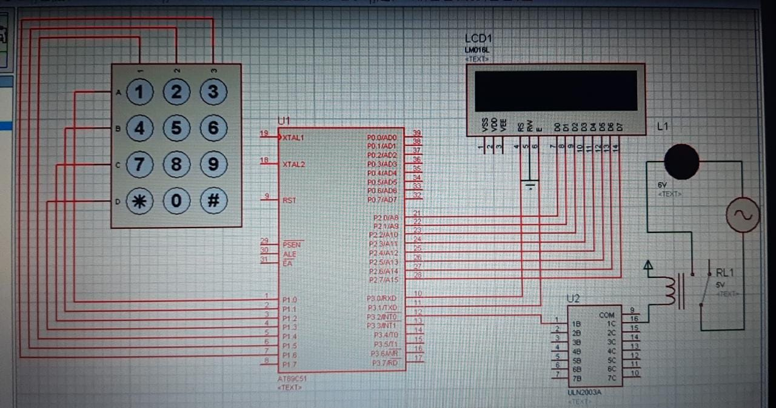

Now after running it will ask us to enter the password.

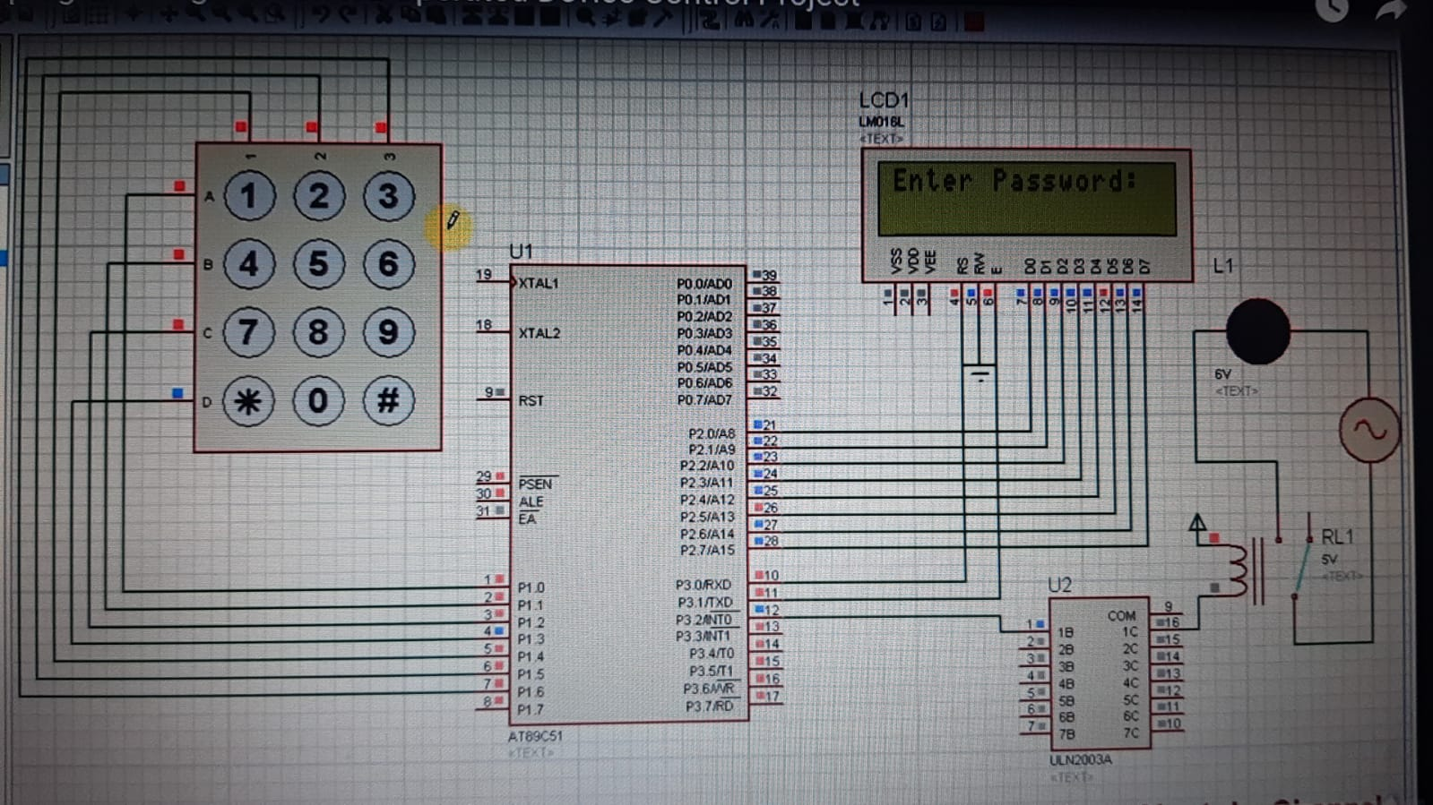

Now we will enter a wrong password first…..we will enter 2222

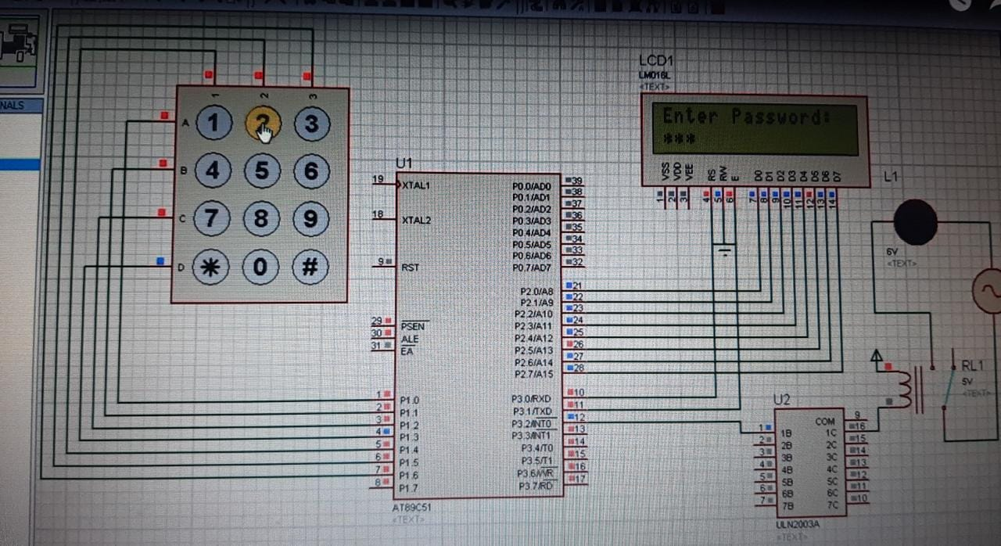

Then it will display wrong password as the correct password is 6666.as we have entered wrong password led will not glow or entry will be denied.

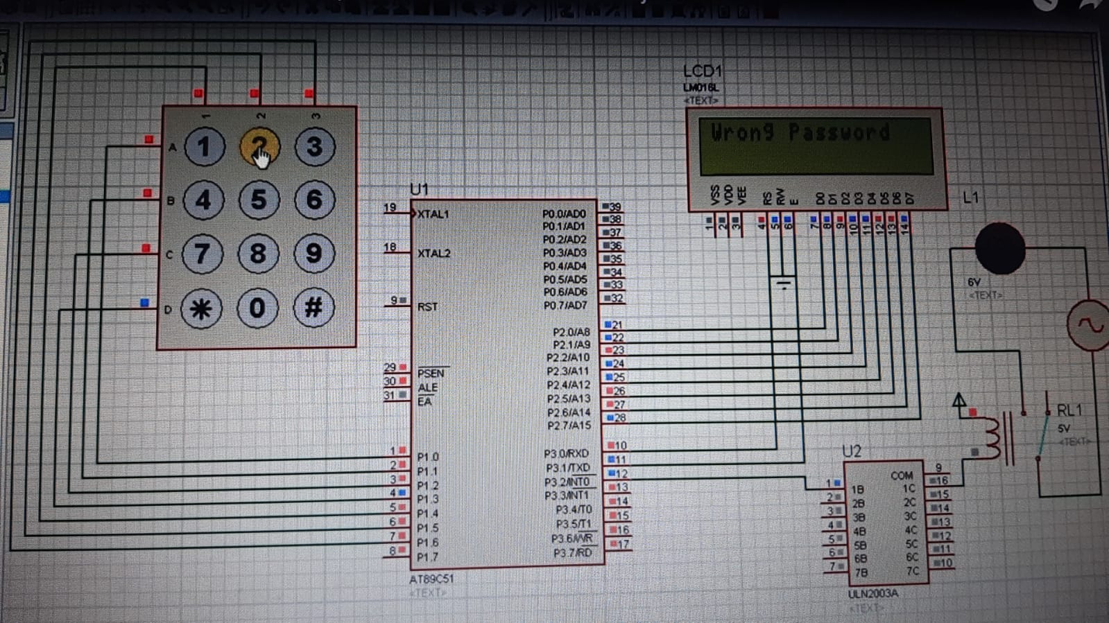

Now in the next attempt we will enter the correct password 6666

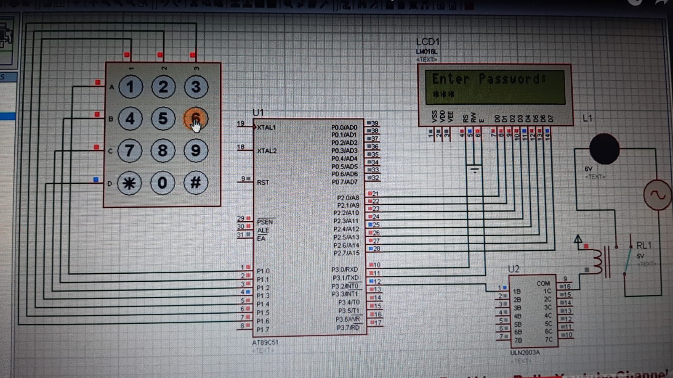

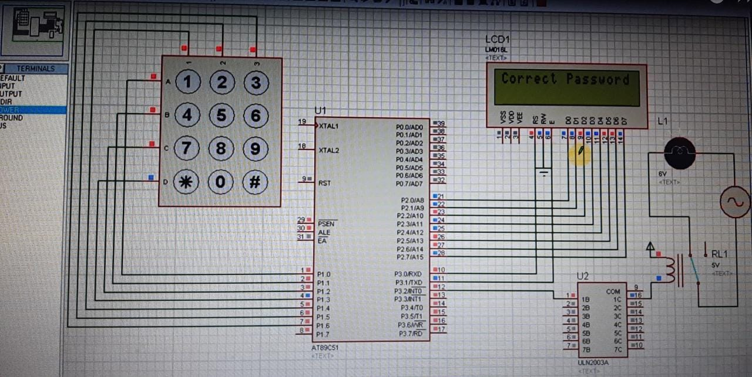

Now the led glows or entry will be accepted. output will be 1 in the case of a correct password.